CLOCKFACE POLYGONS. ANSWERS
How many equilateral triangles can you draw? 4
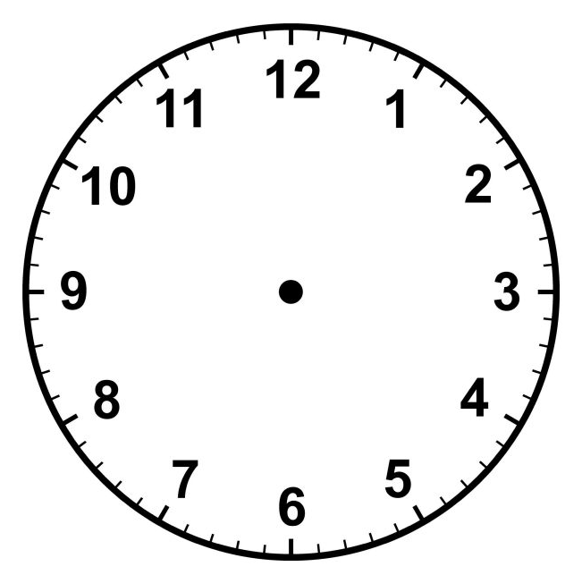
Extention: Draw Star of David
How many Stars of David can be drawn? 2
- How many SQUARES can you draw? 3
(b) If we allow the vertices of the square to not be on the hours we can produce
an Islamic Star.
- Draw a regular HEXAGON
- How many hexagons using only the hours as vertices (only 2)

- How many ISOSCELES triangles could you draw?
If we rotate there are 12 like the above. If we rotate there are 12 more like the above.

If we rotate there are 12 more like the above. If we rotate there are 12 more like the above.
This makes a total of 48 isosceles triangles
NB we should not count the following case because it is equilateral and not JUST isosceles.

If we want a regular PENTAGON in the clock-face, we cannot just use the hours.
Dividing 60 minutes by 5 we get a vertex at every 12 minutes.
One such pentagon would have vertices at 0 (ie 12), 12 min, 24 min, 36 min and 48 min.
If we start rotating this on minutes only, after 12 rotations it would look the same as above so there are 12 regular pentagons.

How many RIGHT ANGLED triangles can be drawn?
This can be done even if students have not yet heard of “angle in a semicircle”. (but it does help and would make a good exercise for Y11 students)
Clearly every diameter could have 5 right angled triangles drawn in one semicircle and 5 more in the opposite semicircle.
We could put a diameter in 6 positions so this makes 60 possible right angled triangles.

How many TRIANGLES can be drawn? (VERY CHALLENGING)
(including scalene, isosceles and equilateral)
B
A
C
Clearly a systematic method is needed.

Starting with A at 12 and B at 11, then the position of C could be at any hour position from 1 to 10.

10 triangles

C
B
A
Keeping A at 12 but moving B to 10, then the position of C could be at any hour position from 1 to 9.

9 more triangles

A
C
B
Similarly, keeping A at 12 but moving B to 9, then the position of C could be at any hour position from 1 to 8.
8 more triangles

Carrying on this way, we see that the total number of triangles if A is a vertex at 12, would be: 10 + 9 + 8 + 7 + 6 + 5 + 4 + 3 + 2 + 1 = 55
This is the total number of triangles which have A as any vertex.

If we moved A to 11 and B to 10, then C could be at any hour from 1 to 9
Keeping A at 11 but moving B to 9, then C could be at any hour from 1 to 8.
Keeping A at 11 but moving B to 8, then C could be at any hour from 1 to 7.
etc
so if A is at 11 there are 9 + 8 + 7 + 6 + 5 + 4 + 3 + 2 + 1 = 45 triangles

Similarly, if A is at 10, there are 8 + 7 + 6 + 5 + 4 + 3 + 2 + 1 = 36

If A is at 9, there are 7 + 6 + 5 + 4 + 3 + 2 + 1 = 28.
If A is at 8, there are 6 + 5 + 4 + 3 + 2 + 1 = 21.
If A is at 7, there are 5 + 4 + 3 + 2 + 1 = 15.
If A is at 6, there are 4 + 3 + 2 + 1 = 10.
If A is at 5, there are 3 + 2 + 1 = 6.
If A is at 4, there are 2 + 1 = 3.
If A is at 3, there is only 1 triangle (joining 3,2 1).
The total number of triangles is 1+3+6+10+15+21+28+36+45+55 = 220

