SUPERB INVESTIGATION SUITABLE AT MANY LEVELS.
(Teacher’s guide)

1. Consider a piece of string 40 cm long.
(a) If we make it into a square its area is obviously 10×10 =100 cm²
10

10 10

10

(b) If we cut the string into two pieces 4 cm and 36 cm and form two squares
find the total area.
1 9
1
9

Total area = 1 + 81 = 82 cm²

(c) If we cut the string into two pieces 8 cm and 32 cm and form two squares
find the total area.
Total area = 2×2 + 8×8 = 68 cm²

(d) Now cut the string into pieces 12 cm and 28 cm.
Total area = 3×3 + 7×7 = 58 cm²

(e) Make a table of values
1st piece | 2nd piece | Area 1st square | Area 2nd square | TOTAL AREA
4 | 36 | 1 | 81 | 82
8 | 32 | 4 | 64 | 68
12 | 28 | 9 | 49 | 58
16 | 24 | 16 | 36 | 52
20 | 20 | 25 | 25 | 50
24 | 16 | 36 | 16 | 52
28 | 12 | 49 | 9 | 58
32 | 8 | 64 | 4 | 68
36 | 4 | 81 | 1 | 82
(f) If the first piece is length x, the other length is 40 – x
Find a formula for the total area:

A = x ² + (40 – x) ²
4 4

= x² + 1600 – 80x + x²
16

= 2x² – 80x + 1600 or x² – 5x + 100
16 8
Draw a graph of this (possibly using Autograph or a Graphics Calculator)
Point out that this is a parabola. (The “right-way- up” type, so it has a minimum value not a maximum.)
Notice in particular that the minimum value is A = 50 when x = 20.

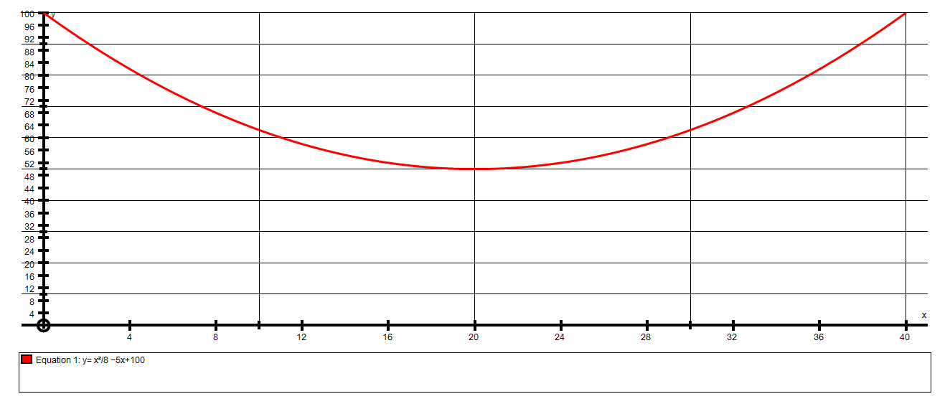
Min(20, 50)

2. Consider a piece of string 40 cm long.(HARDER)
(a) If we make it into a CIRCLE we need to find the RADIUS, in order to
calculate its area.

Students need to know C = 2πr
r so that 2πr = 40
πr = 20
r = 20 ≈ 6.366
π
Area = πr² = π × (6.366)² ≈ 127.3 cm²
(b) If we cut the string into two pieces 4 cm and 36 cm and form two circles
find the total area.

Radius of 1st circle = 2 ≈ 0.6366 Radius of 2nd circle = 18 ≈ 5.73
π π
Area of 1st circle = π×(0.6366)² Area of 2nd circle = π×(5.73)²
= 1.273 cm² = 103.1 cm²

Total area = 104.4 cm²

(c) If the first piece is length x, the other length is (40 – x)
Find a formula for the total area: (Quite complicated for students!)

1st Circle  Circumference = x = 2πr  so r = x  2π  Area = πr² = π × x² = x²  4 π² 4 π | 2nd Circle  Circumference = 40 – x = 2πr  so r = 40 – x  2π  Area = πr² = π × (40 – x)² = (40 – x)²  4 π² 4 π
Total Area = x² + (40 – x)²
4 π 4 π
If we draw this graph we do not have to go through lots of x values to get to the minimum area.
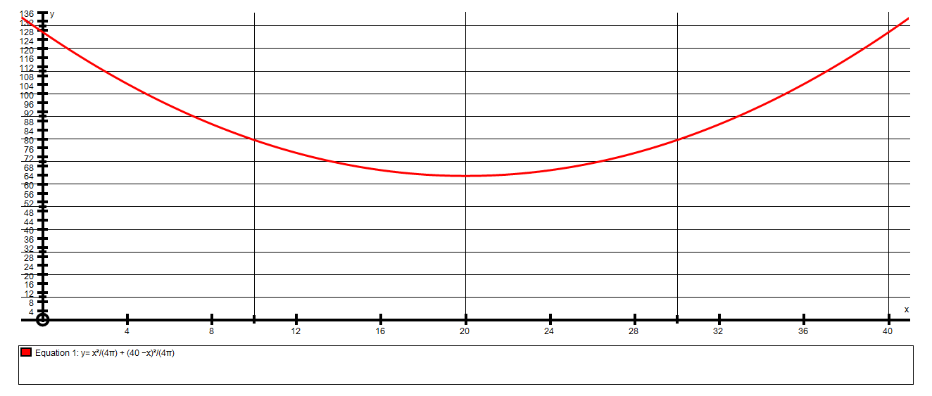
Min (20, 63.66)
Point out that this is a parabola. (The right way up type, so it has a minimum value not a maximum.)
Notice in particular that the minimum value is A = 63.66 when x = 20.

3. (This is where this investigation has been leading.)
A 40 cm piece of string is cut into 2 pieces.
One piece is made into a CIRCLE and the other is made into a SQUARE.
Find the minimum AREA.
Let one piece be of length x and the other is (40 – x)
Let the 1st piece be made into a circle:
Circumference = x = 2πr
so r = x
2π

Area = πr² = π × x² = x²
4 π² 4 π

Let the 2nd piece be made into the square:
Each side will be 40 – x
4
So the area is (40 – x )²
16

Now we will draw the graph Area y = x² + (40 – x )²
4 π 16
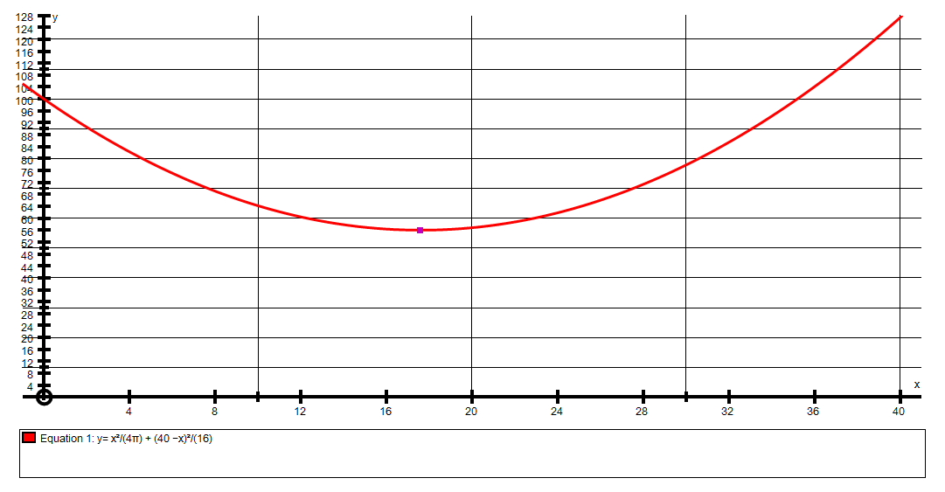
Min (17.6, 56)
Also notice that when x = 40 only a circle is made and its area is 127.3 cm²
Notice when
x = 0
only a square is made and its area is 100 cm²
The minimum Area is 56.01 cm² when x = 17.6 cm
Although we have used a graph program to find this minimum value, this makes a good calculus problem.
Lengths are x and (40 – x). If circumference = x then 2πr = x so r = x
(2π)
Total Area = πr² + (40 – x)²
16
AREA = π x² + 1600 – 80x + x² = x² + 100 – 5x + x² 40 – x
4π² 16 4π 16 4
d(Area) = x – 5 + x = 0 for max Area
dx 2π 8 40 – x
4
x( 1 + 1) = 5
2π 8

x ×0.28415 = 5
x = 17.6 cm so r = 2.8 cm

So Min Area = π×2.8² + 5.6² = 56 cm²

A nice extension to this would be splitting the string into 2 pieces, making a SQUARE with one piece and an EQUILATERAL TRIANGLE with the other.

x x

x
If we let each side of the triangle be x then the area could simply be written as x × x × sin60 = x² √3
2 4

This leaves (40 – 3x) left for the square so each side = 40 – 3x
4

The area of the square = (40 – 3x)² = 1600 – 240x + 9x²
16 16

The total area is A = x² √3 + 1600 – 240x + 9x²
4 16

dA = x√3 – 15 + 9x = 0 at min area
dx 2 8

x(√3 + 9 ) = 15
2 8

x ≈ 7.53

Min A ≈ 43.5 cm²

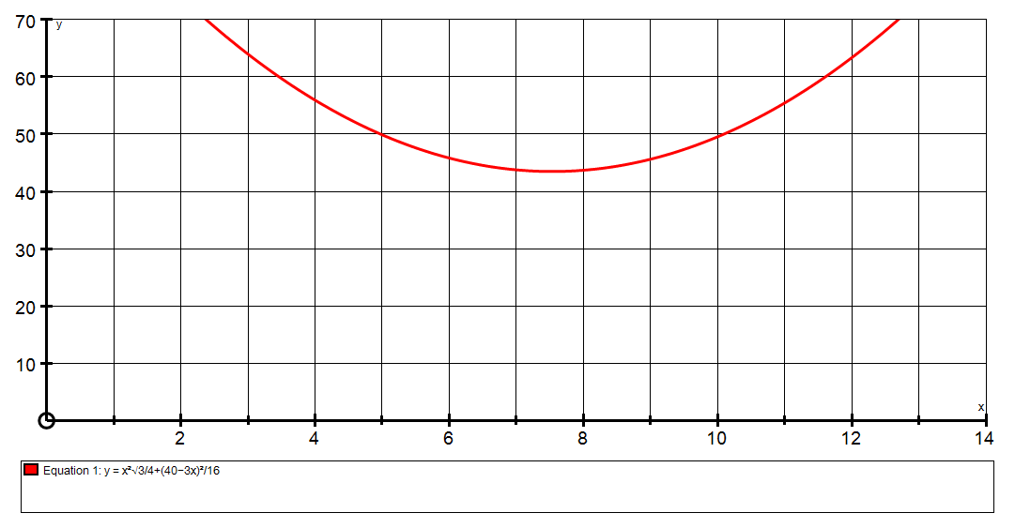
Min (7.53, 43.5)

