CLOCKFACE POLYGONS.

Using a basic clock face, try to draw the shapes required but you must keep the vertices or corners on the hour numbers 1 to 12 and not between, unless specifically asked for.
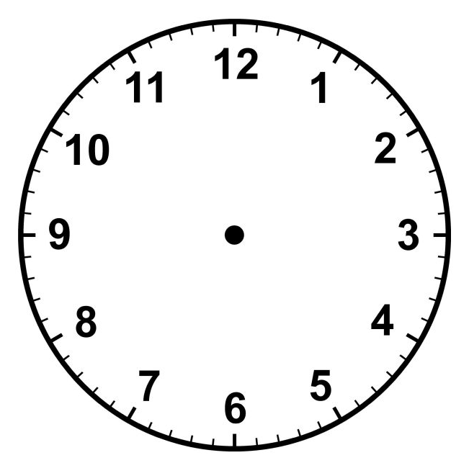
eg ALLOWED NOT ALLOWED
(a) How many equilateral triangles can you draw?

Extention: Draw Star of David on a clock face.
How many Stars of David can be drawn?
(b) How many SQUARES can you draw only on the hour numbers?
Extention: To draw a square in this position:
you cannot do it on the hours.
Find its exact position on the clock face.

Now draw an Islamic Star:

(c) Draw a regular HEXAGON

How many hexagons can be drawn using only the hours as vertices?

(d) How many ISOSCELES triangles could you draw?
(not counting equilateral triangles)

(e) If we want a regular PENTAGON on the clock face, we cannot
have the hour numbers for all the vertices.
Find the exact positions for the vertices.

(f) How many RIGHT ANGLED triangles can be drawn?

(g) VERY CHALLENGING: How many triangles can be drawn including scalene, isosceles, equilateral and right angled?

