Using Formulas for REAL SITUATIONS.
(worksheet or teacher’s notes)
1. If you throw an object up in the air at any angle, the greatest height it reaches, H, and the time the object is in the air, T, are related by this simple formula : H = 5T² (ignoring any air resistance)
4
A rugby player did a “place kick” to convert a try and the ball was in the air for 4.6 sec. Use the above formula to find the greatest height that the ball reached. H =

TEACHER: Get stop watches and cricket balls or some stones to throw. Go to a wide open flat space. One person throws the ball as high as possible, the timers carefully find the time from the ball leaving the thrower’s hand to the time it hits the ground. It does not matter at what angle the ball is thrown!
eg If T = 3.4 sec then H = 14.45 metres.
You could have a class competition to find the highest thrower.
___________________________________________________________
2. HOW FAR CAN YOU SEE?
The distance of the horizon depends on how far off the ground you are.
The person up high can see to Q.

The lower person can only see to P

The distance you can see, D km,
is given by : D = 3.5 × √ H

where H is the height of your
eyes from the ground, in metres.
P
Q
(a) If you stand on the beach at the water’s
edge and your eyes are at a height of 1.64 metres
Curvature of the Earth.
find how far you can see out to sea.
D =
(b) If you climb up a cliff by the beach and your eye level is now
39 metres above the sea level, how far can you see now?

D =

____________________________________________________
3. If a car goes round a corner too fast, it will turn over. To find out what speed is needed to turn over the car we need to know:
(a) the radius of the curve, r metres.
(b) the sideways distance between the wheels, d metres.

The speed in Km/hour, V is : V = 3.6 × √10dr

A “boy racer”, ignorant of this equation, goes round a corner of radius 19 m and the distance between his wheels is 1.8 m.
If he goes at 70 Km/hr will his car turn over?

_____________________________________________________________________________

4.(a) A bungy chord is 40 m long and so a person falls 40 m freely
before the chord starts to slow him/her down.

The speed V after falling h metres is V = 3.6 ×√ 20 h
where V is in Km/ hr and h is in metres. (ignoring air resistance)

Find what speed the bungy jumper is traveling at the instant
the chord starts to stretch.
V =
_________________________________________________________

(b) Find what speed you would hit the ground if you jumped off:

(i) the C.N. Tower in Toronto = 553m.
V =

(ii) the Eiffel Tower in Paris = 320m.
V =

(iii) the Sky Tower in Auckland = 350m
V =

___________________________________________________________

5. The height of a building can be found by dropping a stone from the top
and finding the time it takes to hit the ground.
The formula is : H = 5T² where T is in seconds and H is in metres.
It is hard to believe, but small objects fall just as fast as big, heavy objects. (neglecting air resistance)
(On the moon, where there is no air, a feather would fall at the same rate as a canon ball!)

(a) If a stone is dropped from the top of a building and it takes
7.07 seconds to reach the ground, find the height of the building.

(b) If a stone is dropped off a building 350 m high find how long it
would take to reach the ground.
(use the same formula in reverse)
___________________________________________________________

6. In some movies you see a car or motorbike becoming air-borne as it goes over the top of a hill, like in San Francisco or those little hump-back bridges. The speed just depends on the radius of curvature of the hill and it does not matter how heavy the car or motorbike is.

r r

The formula is V = 3.6 × √ (10 r) V is in Km/hr , r is in metres.
The stunt drivers actually have mathematicians or scientists who carefully work out the necessary speeds before filming begins.
Find the necessary speeds if :
(a) r = 20m

(b) r = 40m

(c) r = 60m
___________________________________________________________
7. The greatest distance you can throw a ball or a stone is when you throw it at an angle of 45⁰ and the horizontal distance that the ball hits the ground is D = V² where D is in metres and V is m/s
10
V

45⁰
D
Find the maximum distance you could throw a ball if :

(a) V = 12 m/s

(b) V = 18 m/s

(c) V = 25 m/s
__________________________________________________________

8. MOTOR CYCLE JUMPS.
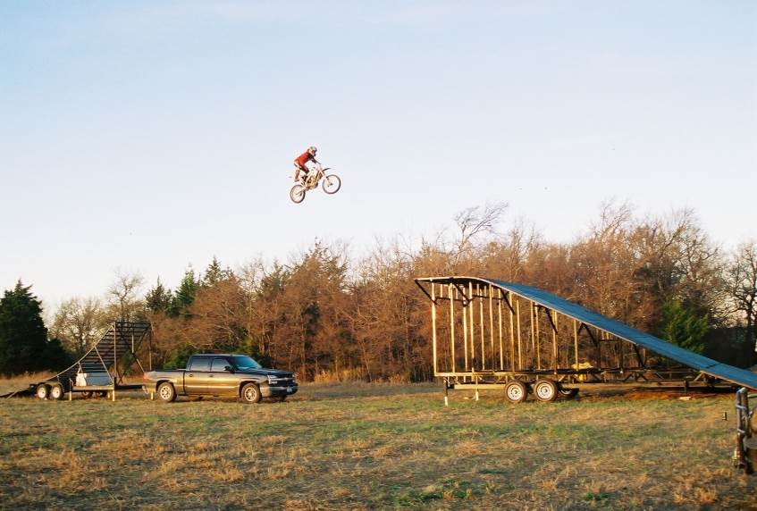
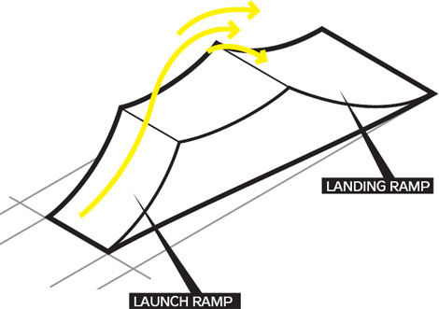
The distance R that can be reached
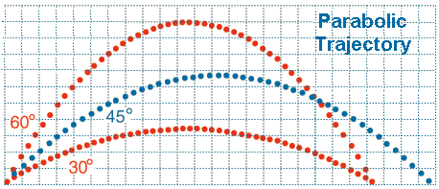

Max R
depends on the angle of the ramp α
and the velocity V of the “take-off”.
The formula is:
R = V² sin2α
g g
where g is the acceleration due to gravity.
(g ≈ 9.8 m/s/s but we often use g ≈ 10 m/s/s)
R is in metres and V is in m/s (not km/h)))))))))
1 m/s = 3.6 km/h

- Suppose α = 30⁰, V = 20 m/s = 72 km/h
then R = 20² sin 60 ≈ 35.3 metres
9.8
(b) Suppose α = 45⁰, V = 20 m/s = 72 km/h
then R = 20² sin 90 ≈ 40.8 metres
9.8
(this is the maximum distance for this speed on this ramp)

(c) Suppose α = 60⁰, V = 20 m/s = 72 km/h
then R = 20² sin 120 ≈ 35.3 metres
9.8
(d) The world record for the distance R travelled through the air was done on a
ramp of only 15⁰ and the take-off speed was 165 km/h ≈ 45.83 m/s
Find the distance R

R = (45.83)²sin30 ≈ 107 metres!
9.8
See the jump https://www.youtube.com/watch?v=sSvvOxV4e3M

