Converting between Fahrenheit and Celsius temperature scales Mentally.
On a recent trip to the USA I found it frustrating mentally converting the temperatures from the Fahrenheit scale to the more familiar Celsius scale.
There is no problem if you have a calculator on hand but the formula can be awkward when trying to work out a quick answer.

Basically, the freezing point of water in Fahrenheit is 32⁰F and in Celsius it is 0⁰C
The boiling point of water in Fahrenheit is 212⁰F and in Celsius it is 100⁰C.
The linear graph is as follows:
⁰F

212

180

32
100

0 100 ⁰C

The gradient of this line is 180 or 9 or 1.8
100 5
The “y” intercept is 32

If we want to change from degrees C to degrees F, the most convenient formula is:
F = 1.8C + 32 or F = 9C + 32
5
If we want to change from degrees F to degrees C it is more convenient to transpose the formula to the form:

C =5× (F – 32)
9

On my trip, a typical temperature in Arizona was 35⁰C which amounts to
F = 9×35 + 32 = 95 in Fahrenheit.
5
The temperature range was often between 25⁰C and 45⁰C
which is 77⁰F to 113⁰F

If the temperature were 39⁰C the calculation would be 9 × 39 + 32
5
which is a little awkward to do mentally.
However if we notice the gradient of the graph is close to 2, the calculation would be much easier to do mentally.

The proper formula is F = 1.8C + 32
and if we make the approximation F = 2C + “something”, we will need to work out a value for the “something” which fits the temperature range.
Since we know that 35⁰C = 95⁰F we can use this as a guide:

95 = 2 × 35 + “something”
95 = 70 + “something”
So the approximate formula to use is F ≈ 2C + 25
or transposed, we get C = (F – 25)
2
If I draw the two graphs accurately, we see that they fit very closely in the required temperature range. The RED line is the exact line.
The BLUE line is the approximation.
⁰F
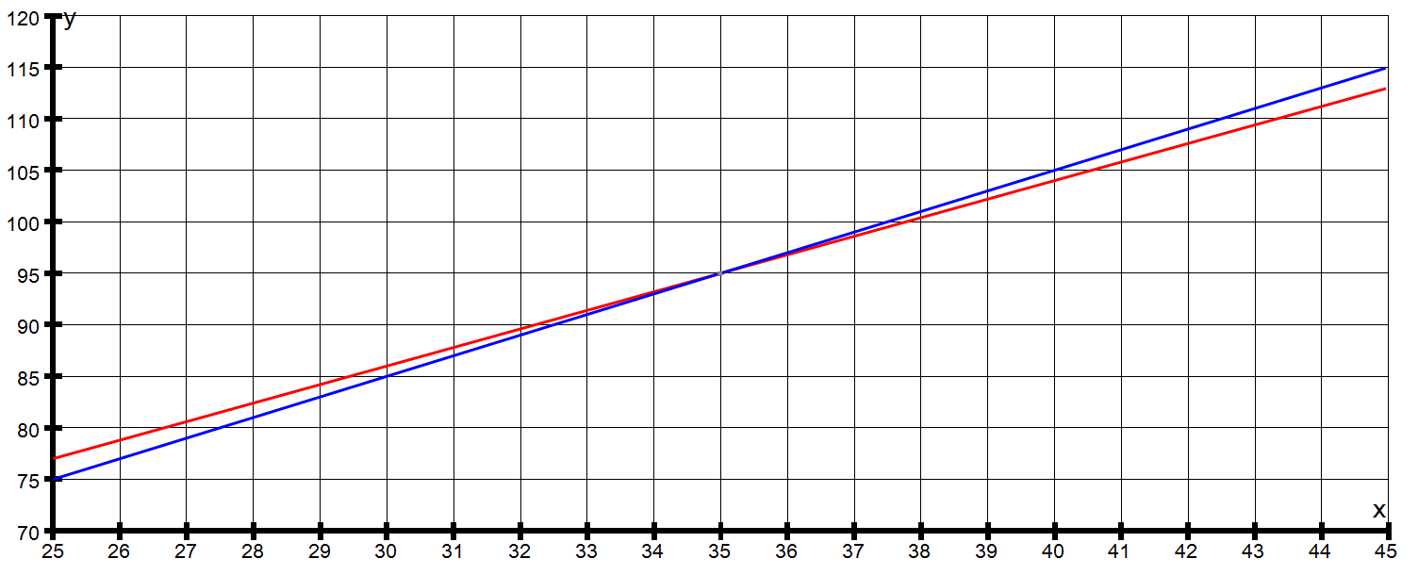⁰C
2⁰

Considering the 39⁰C from above we see that the exact number in ⁰F = 102.2⁰
And our approximate formula gives 2×39 + 25 = 103⁰

For temperatures close to 35⁰C the approximations are very close.
At the extreme ends of the range, the approximations are within 2⁰F

Exact Celsius | Exact Fahrenheit | Approx Fahrenheit
25 | 77 | 75
35 | 95 | 95
45 | 113 | 112

This method will work for any restricted temperature range.
Consider the case of a winter period where the temperature averages 5⁰C and varies between 0⁰C and 10⁰C
Celsius | Fahrenheit
0 | 32
5 | 41
10 | 50

Finding an approximate equation, let F = 2C + p
Subs C = 5, F = 41
41 = 10 + p so p = 31
The approximate equation is F = 2C + 31
As you can see the graphs are very close for this range of temperatures.
The RED line is the exact line.
The BLUE line is the approximation.
⁰F
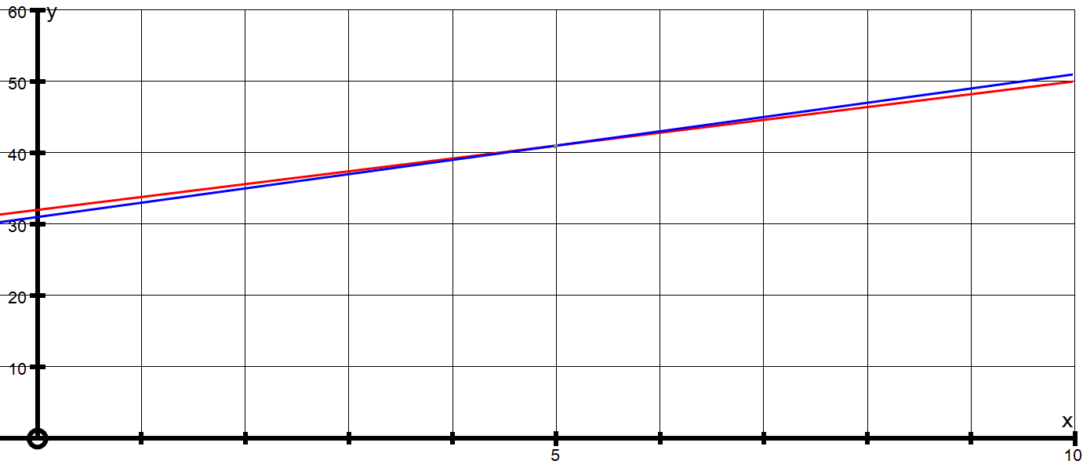⁰C

Exact Celsius | Exact Fahrenheit | Approx Fahrenheit
0 | 32 | 31
5 | 41 | 41
10 | 50 | 51

Some interesting points:

There is a temperature which is the same number in the Fahrenheit and Celsius scales.

Let T ⁰C = T ⁰F

Then T = 9T + 32
5
So 5T = 9T + 160
– 160 = 4T
T = – 40
This means – 40⁰F = – 40⁰C
___________________________________________________________

Also we find that 16⁰C ≈ 61⁰F (just change the numbers round!)
Also 28⁰C ≈ 82⁰F

There are no other pairs which behave like this.
___________________________________________________________

